<https://www.cambly.com/en/student/courses/5eb03d0f9934e038cfcf0372/5eb03d451bfbfd36bafad4ef>

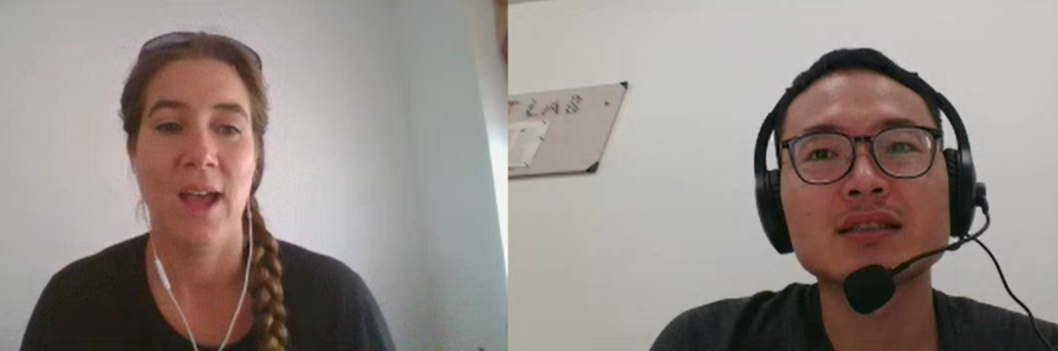

## notes

|  |  |  |
| --- | --- | --- |
| Obstacle  barrier | /ˈɒbstək(ə)l/  /ˈbæriə(r)/ |  |
| Job security  Unstable  Temporary contract  permanent | /sɪˈkjʊərəti/  /ˈkɑːntrækt/  /ˈpɜːmənənt/ | Security: the state of being free from danger or injury;  Contract:a binding agreement between two or more persons that is enforceable by law  Permanent:continuing or enduring without marked change in status or condition or place |
| Manufactured by China | /ˌmænjuˈfæktʃəd/ | produced in a large-scale industrial operation  Manufactured landscapes  人造景  Manu-factured product |
| property | /'prɔpəti/ | any area set aside for a particular purpose |
| globalization | /ˌɡləʊbəlaɪˈzeɪʃn/ |  |
| regulation | /ˌreɡjuˈleɪʃn/ |  |
| To adapt |  |  |
| To export  To import |  | Enter  exit |
| To integrate  merge | /ˈɪntɪɡreɪt/ |  |
| advertising | /ˈædvətaɪzɪŋ/ |  |
| competitor | /kəmˈpetɪtər/ | [rival、](javascript:;) [challenger、](javascript:;) [competition、](javascript:;) [contender](javascript:;)  the contestant you hope to defeat |

|  |  |  |
| --- | --- | --- |
| unpredictability | /ˌʌnprɪˌdɪktəˈbɪləti/ | the quality of being guided by sudden unpredictable impulses |
| flexible |  | You need to be more flexible and imaginative in your approach. |

## lesson

